Design

Document

Online PG Rental System

**Index**

|  |  |  |
| --- | --- | --- |
| Sr No | Content | Page No |
| 1 | Introduction | 3 |
| 2 | Architectural Design | 3 |
| 3 | High Level Design | 5 |
|  | 3.1 E-R Diagram | 5 |
|  | 3.2 Page Navigation Diagram | 7 |
|  | 3.3 Data Flow Diagram | 10 |
| 4 | Low Level Design | 11 |
|  | 4.1 Database Design | 13 |

1. **Introduction:**

This document is meant for the description of the structure and the database which we are using in this project. This document gives brief description about Architecture of the system, E-R diagram of the system and the table descriptions, the page navigation diagrams and the detail description for the page navigation.

1. **Architectural Design:**

Following diagram shows the details of the Online PG Management system architecture.

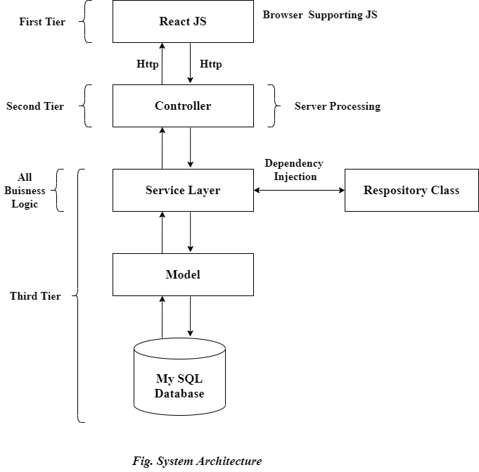

This System consist of three tiers as listed below,

* First tier
* Second tier
* Third tier

**First Tier:**

This tier is used for user interface and it is called as client tier. In this tier we are using React JS because of it provides better interactivity, easier navigation, compact. The use of java script facilities us for the client side validation. That’s why in first tier we are using the java scripts.

**Second Tier:**

In this part of second tier we are using Controller’s, it provides a centralized entry point that controls and manages Web request handling. By centralizing decision points and controls, the controller also helps reduce the amount of Java code.

**Third Tier:**

Third tier consist of service layer and the model classes and the database of Online PG Management system.

**Service Layer and Model Classes:**

Service layer has proven good in separate business logic layer. All the logic on data is mapped to JPA with model classes. A JSP page is returned to the user if no error occurred.

**Database:**

All the Crud operations are performed on this MySQL database.

1. **High Level Design:**
   1. **E-R Diagram:**

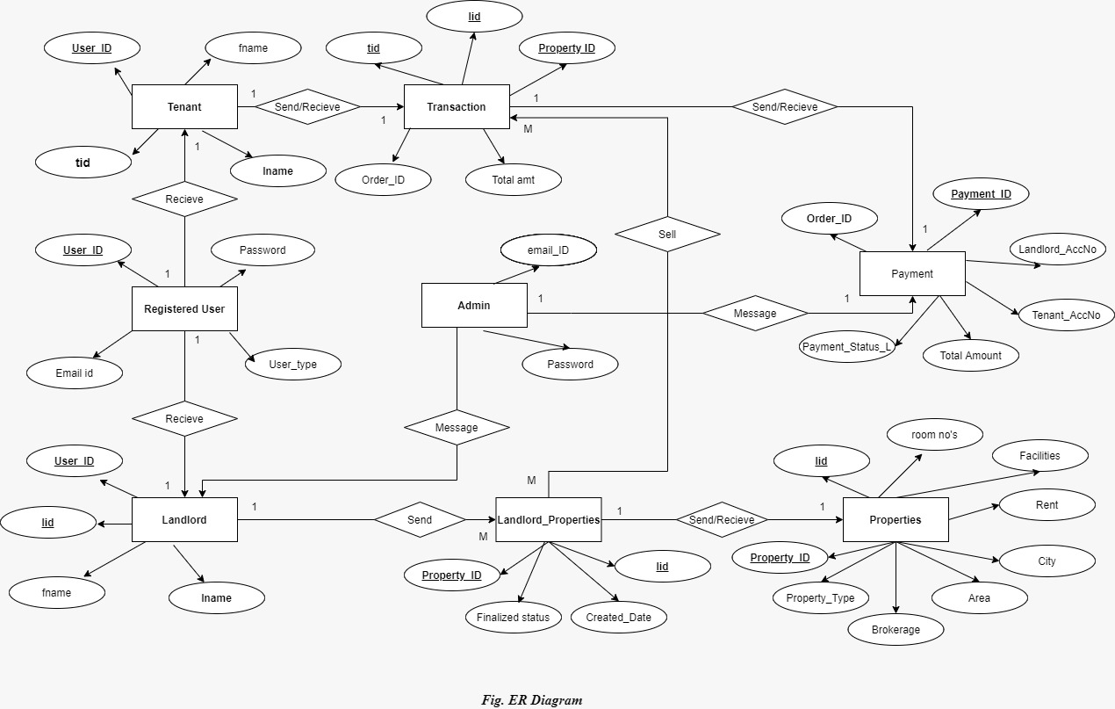

Above E-R Diagram shows that database of Online PG Management system consist of following entities:

* **Registered User**

This entity contains the user_id ,email_id, password, user_type.

* **Tenant**

This entity contains the tid, user_id, fname, lname.

* **Landlord**

This entity contains the lid ,user_id ,fname, lname.

* **Landlord_properties**

This entity contains the pr_id, lid, cr_date , status.

* **Properties**

This entity contains the pr_id, lid ,pr_type , area, city, rent,brokerage

,facilities , room_nos.

* **Admin**

This entity contains the email_id,password.

* **Transaction**

This entity contains oid ,total_amount , tid,lid,pr_id.

* **Payment**

This entity contains the pay_id , oid ,accno_t ,accno-l , total_amount , payst_l.

* 1. **Page Navigation Diagram:**
* **Tenant**

Following diagram explains the page navigation for the Tenant module:

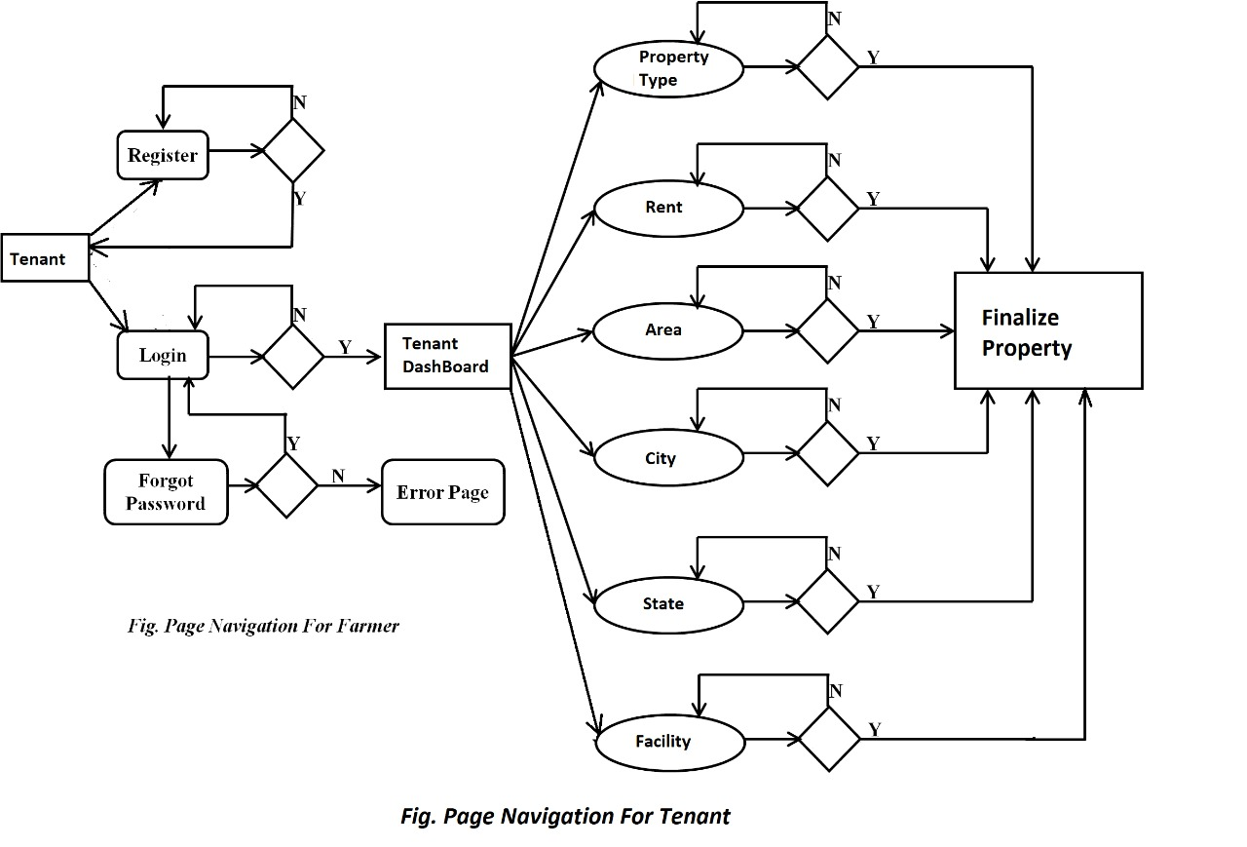

* **Landlord**

Following diagram explains the page navigation for the Landlord module:

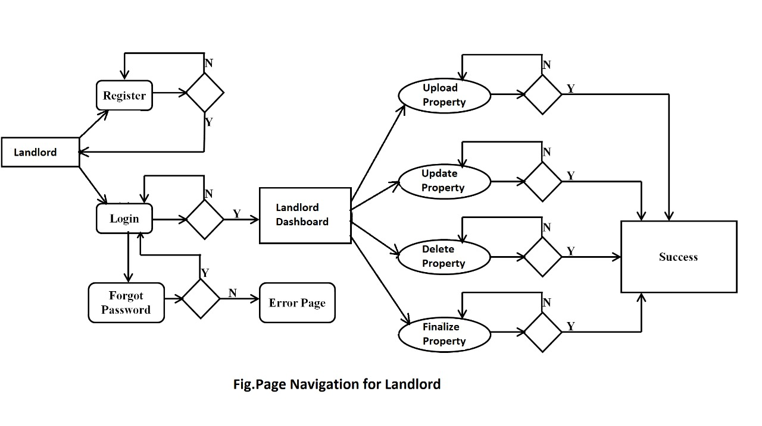

* **Admin**

Following diagram explains the page navigation for the Admin module:

``

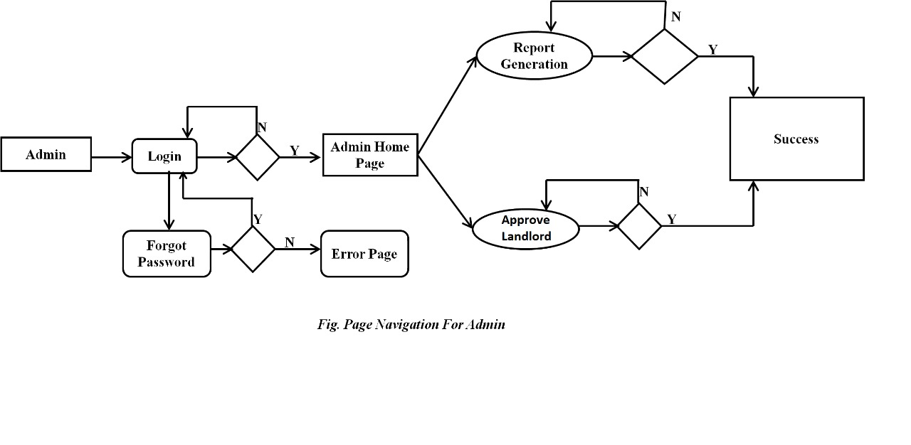

**3.3 Data Flow Diagram:**

* **0-Level DFD:**

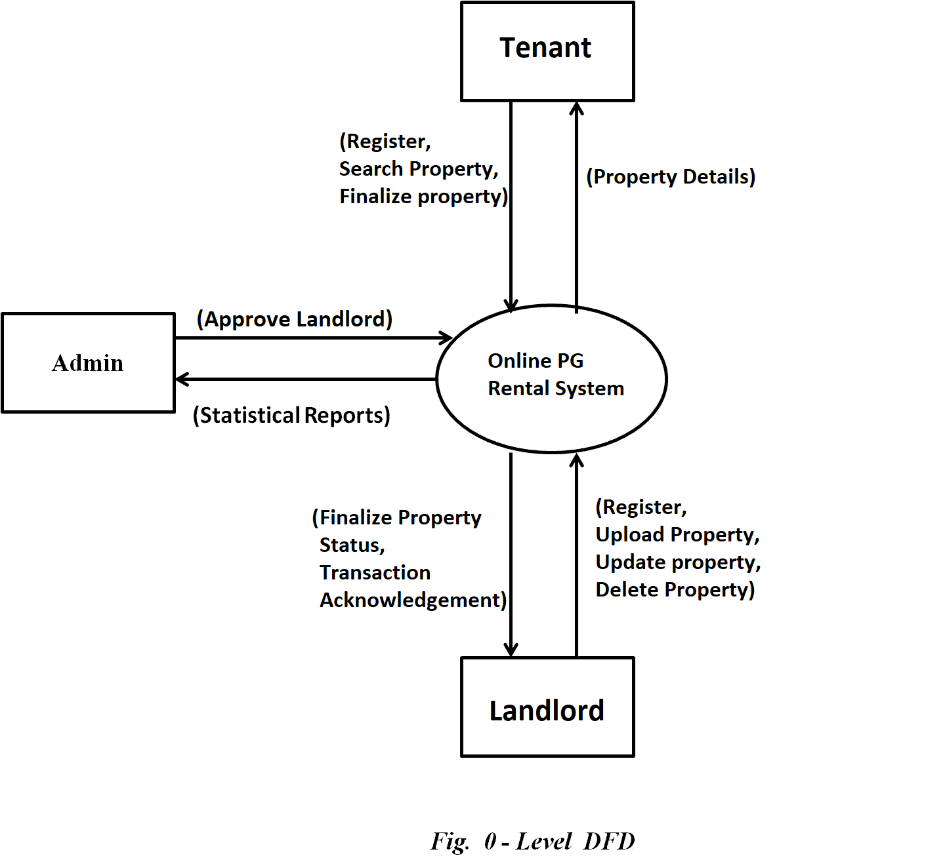

* In 0-Level DFD, there are three Entities:
* Tenant
* Landlord
* Admin

1. **Low Level Design:**
   1. **Database Design:**

**1] Tbl_registered_user**

|  |  |  |  |  |  |
| --- | --- | --- | --- | --- | --- |
| **Field** | **Type** | **Null** | **Key** | **Default** | **Description** |
| user_id | Integer | No | Primary key | Null | User ID |
| email_id | Varchar(20) | No |  | Null | Email ID Of User |
| user_type | Varchar(20) | No |  | Null | Type of User |
| Password | Varchar(15) | No |  | Null | Account Password |

**2] Tbl_landlord**

|  |  |  |  |  |  |
| --- | --- | --- | --- | --- | --- |
| **Field** | **Type** | **Null** | **Key** | **Default** | **Description** |
| lid | Integer | No | Primary key | Null | Landlord id |
| User_id | Integer | No |  | Null | User id |
| fname | Varchar(45) | No |  | Null | Landlord’s first name |
| lname | Varchar(45) | No |  | Null | Landlord’s last name |

**3] Tbl_Tenant**

|  |  |  |  |  |  |
| --- | --- | --- | --- | --- | --- |
| **Field** | **Type** | **Null** | **Key** | **Default** | **Description** |
| tid | Integer | No | Primary key | Null | Tenant id |
| user_id | Integer | No |  | Null | User id |
| fname | Varchar(45) | No |  | Null | Tenants first name |
| lname | Varchar(45) | No |  | Null | Tenants last name |

**4] Tbl_LandlordPorperties**

|  |  |  |  |  |  |
| --- | --- | --- | --- | --- | --- |
| **Field** | **Type** | **Null** | **Key** | **Default** | **Description** |
| Pr_id | Integer | No | Primary key | Null | Property Id |
| lid | Integer | No |  | Null | Id of the landlord |
| Cr_date | Datetime | No |  | Null | Date and time when property registered |
| status | Varchar(20) | No |  | Null | Status of the property |

**5] Tbl_Properties**

|  |  |  |  |  |  |
| --- | --- | --- | --- | --- | --- |
| **Field** | **Type** | **Null** | **Key** | **Default** | **Description** |
| Pr_id | Integer | No | Primary key | Null | Id of the property registered |
| lid | Integer | No | Primary Key | Null | User id of User |
| pr_type | Varchar(45) | No |  | Null | Type of property |
| area | Varchar(45) | No |  | Null | Area of the property |
| city | Varchar(45) | No |  | Null | City in which property resides |
| rent | Integer | No |  | Null | Rent of property |
| brokerage | Float | No |  | Null | Brokerage on the property |
| facilities | Varchar(100) | No |  | Null | Facilities available in the property |
| room-nos | Integer | No |  | Null | Available rooms |

**6] Tbl_Transaction**

|  |  |  |  |  |  |
| --- | --- | --- | --- | --- | --- |
| **Field** | **Type** | **Null** | **Key** | **Default** | **Description** |
| oid | Integer | No | Primary key | Null | Order id |
| total amount | Integer | No | Primary key | Null | Total amount |
| tid | Integer | No |  | Null | Tenant id |
| lid | Integer | No |  | Null | Landlord id |
| pr_id | Integer | No |  | Null | Property id |
|  |  |  |  |  |  |
|  |  |  |  |  |  |

**7] Tbl_payment**

|  |  |  |  |  |  |
| --- | --- | --- | --- | --- | --- |
| **Field** | **Type** | **Null** | **Key** | **Default** | **Description** |
| Pay_id | Integer | No | Primary key | Null | Payment id |
| oid | Integer | No | Primary key | Null | Order id |
| accno_t | BigInt | No |  | Null | Tenants accno |
| accno_l | BigInt | No |  | Null | Landlords accno |
| total_amount | Integer | No |  | Null | Total amount |
| payst_l | Varchar(45) | No |  | Null | Status of the payment |

**8] Tbl_Admin**

|  |  |  |  |  |  |
| --- | --- | --- | --- | --- | --- |
| **Field** | **Type** | **Null** | **Key** | **Default** | **Description** |
| email_id | Varchar(45) | No | Primary key | Null | Admin email id |
| password | Varchar(45) | No |  | Null | Account password |